ASSIGNMENT 6.3

Task Description #1: Classes (Student Class)Scenario
You are developing a simple student information management module
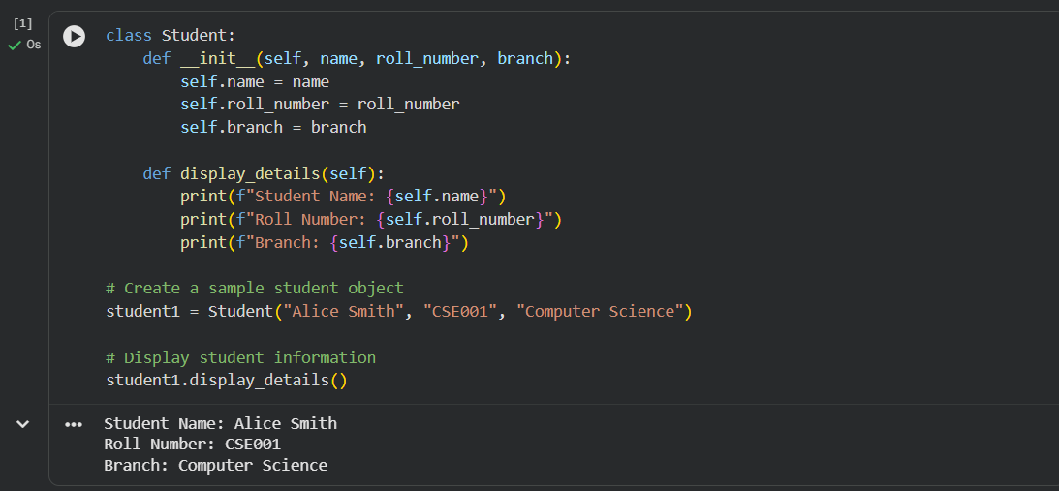
Task Description #2: Loops (Multiples of a Number)
Scenario
You are writing a utility function to display multiples of a given number
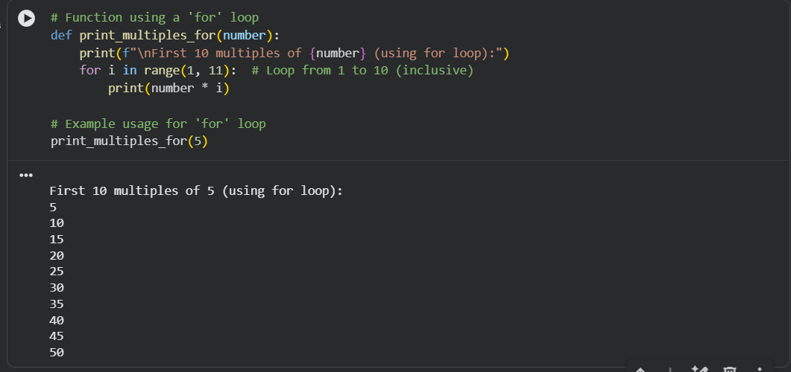
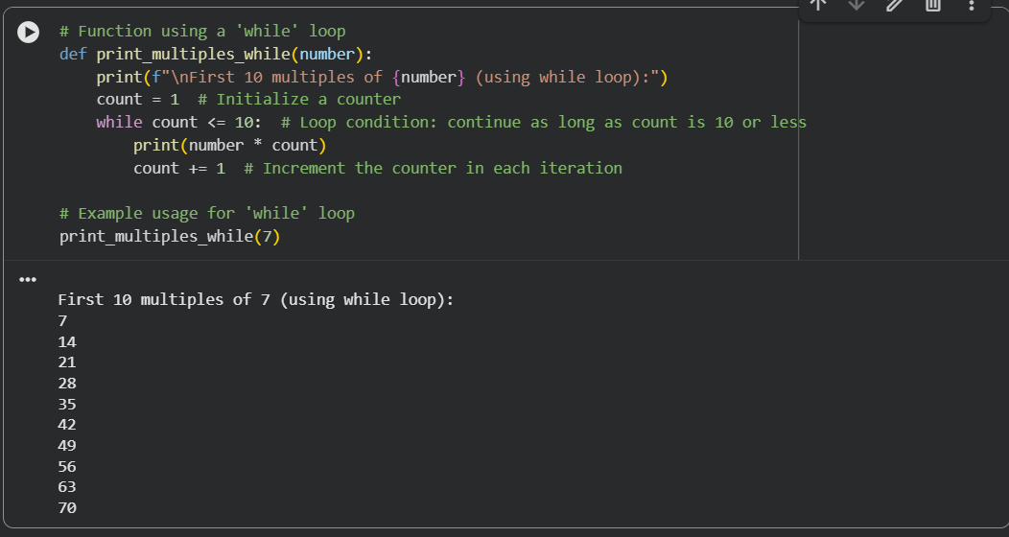
Task Description #3: Conditional Statements (Age Classification)
Scenario
You are building a basic classification system based on age.
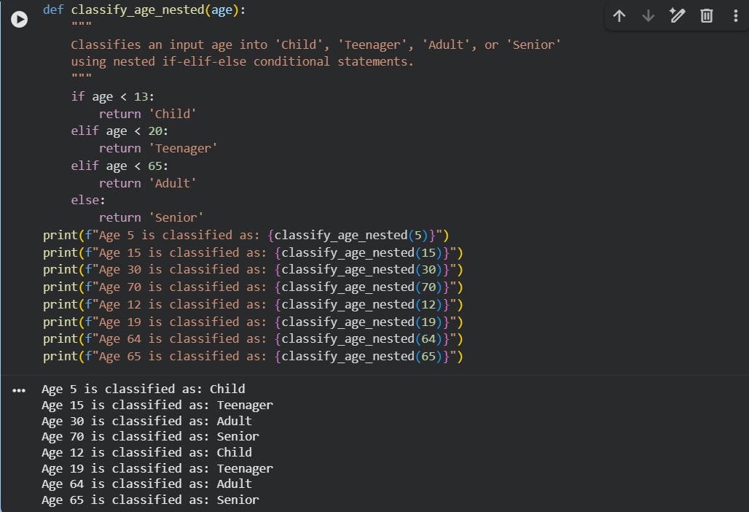
Task Description #4: For and While Loops (Sum of First n Numbers)
Scenario
You need to calculate the sum of the first n natural numbers.
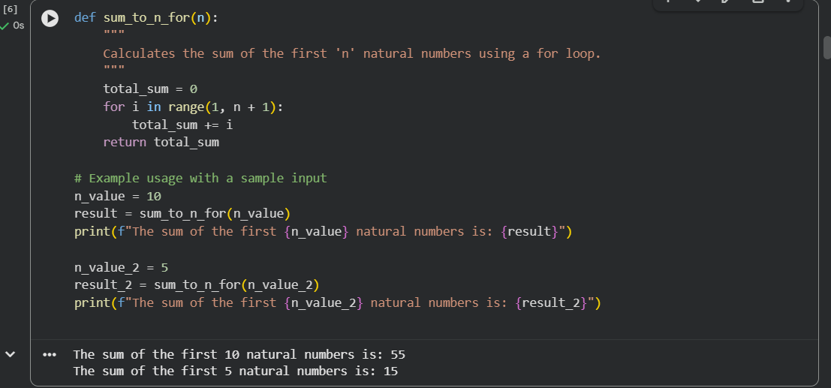
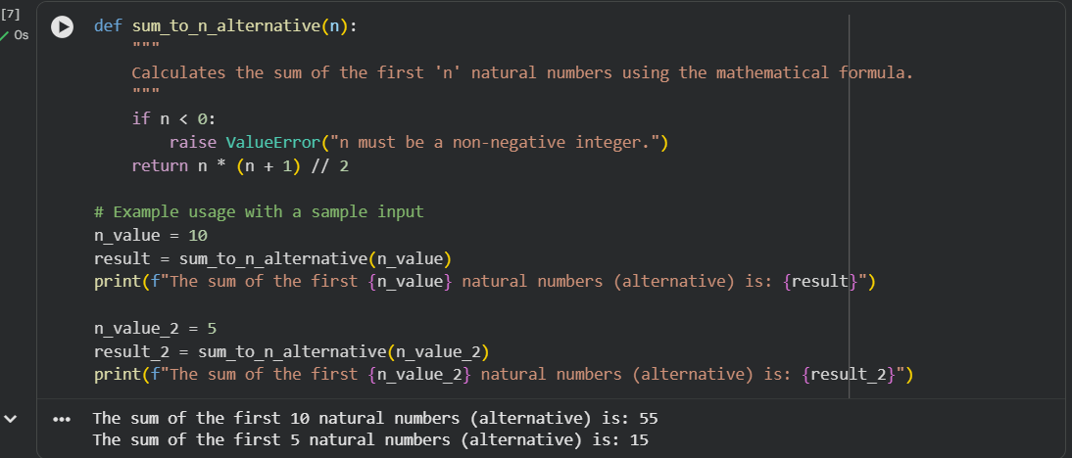
Task Description #5: Classes (Bank Account Class)
Scenario
You are designing a basic banking application
